**Data requirements of TTi: What are the critical data requirements based on your understanding of TTI business scenario described above.**

1. **Key Entities and their relationships**
2. **A conceptual data model in MySQL**
3. **Key Assumptions made while preparing the data model**
4. **Requirements**

Company wants to keep a track of information of its branches, employees, products, manufacturers, sales, inventory. Company has several Employees and branches. Company has Company ID, name, address, city, state, zip, phone email address. Each branch has one or several departments and has Branch ID, Branch head, address, city, state, zip, phone email address .Each Employee has Unique Employee-ID assigned to them and belongs to one department, and have the following attributes employee first name, last name, designation, salary, address, city, state, zip, phone email address. Department consists of id and name.

Company purchases its parts from manufactures and each part type is supplied by one manufacturer. Each part has Part ID, Name, price, description, date of manufacture. Manufacturer has ID, Name, address, city, state, country, zip, phone email address. Each Product consists of many parts but one partid is used in one product only. Product consists of productid, name, assembly date, model, description, cost. Product package consists of many products and products can be in one or many packages. Product packages are stored in warehouses and warehouses have ID, address, city, state, zip, phone email address, dispatch date, receiving date of packages and parts.

Customers are offered 5 different packages and subscription plans. Each customer can purchase one or many packages. Each customer can have many or no repair plans. Customer has Customer id, type, name, gender, city, state, zip, phone email address, DOB, payment details. Customer can have many or no Subscription plans. SMB customer can enroll into a special subscription plan category of three-year lease agreement. Details like start and end date are recorded in the subscription plan. Replacement of old parts are also kept track by recording the Repair work which has Repair id, date.

Sales of the company take place in every branch. Each branch has many or no sales. Each sale is recorded by an invoice id, date, price, quantity, employee id. Each customer who buys a product has an invoice. Customer who visits the store need not buy anything.

1. **Entities and relationships**

After finalizing the data requirements, we were able to summarize the model into 14 entities and their several attributes. Each entity has some relationship with other entities, it could be a direct or indirect relationship. The relationships are either strong or weak. The relationship among the entities are either one to many, many to many, one to one or many to one. All the 14 entities, their attributes and the relationships are drawn below.

1. 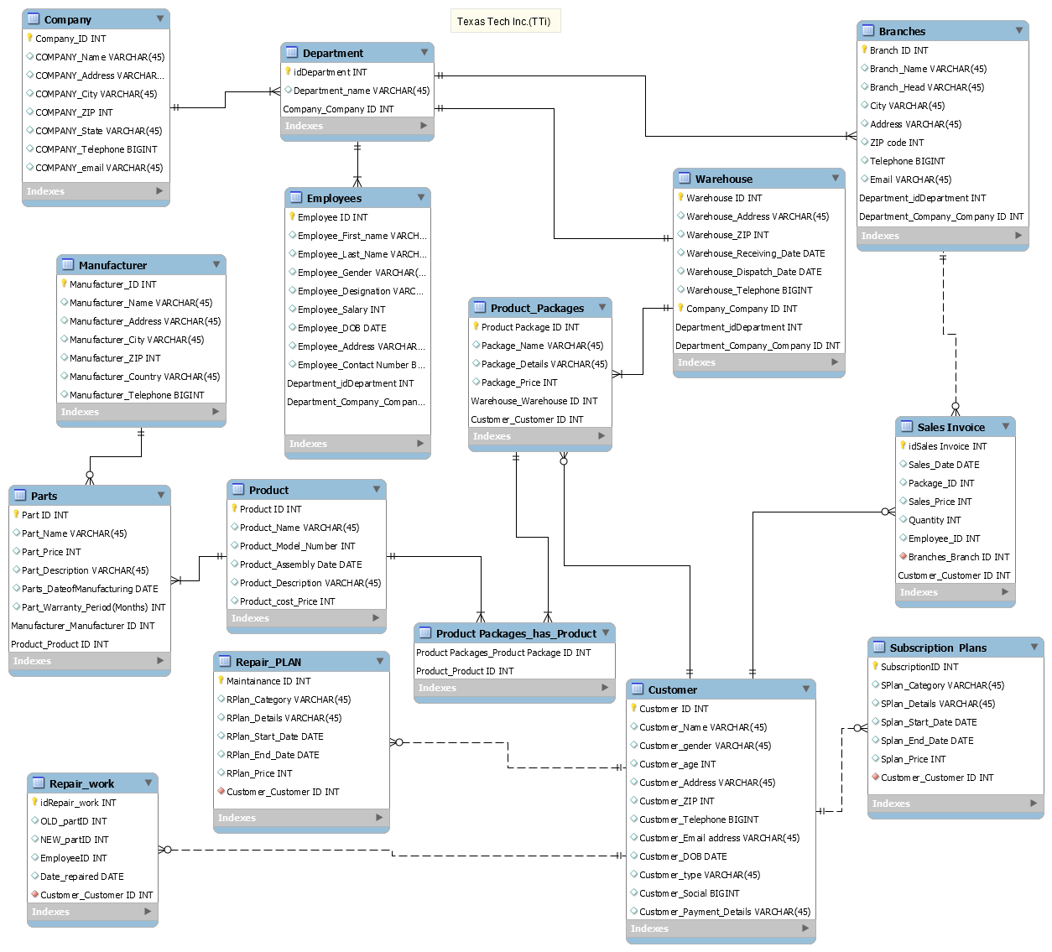**Conceptual Model (ER-Diagram)**

**4. Assumptions**

TexTech Inc. (TTi) have several branches in different cities. The manufacturer/supplier of TTi can provide either zero or many parts but one part can come from one and only one manufacturer. In addition, a part could be in many products and a product can be made from one to many parts. We are considering that they are only selling in packages and not individual part or product.

A product could be in one to many packages and a package can have several products. We have also assumed that product package must be packaged together at the warehouse. The sales are taking place at the branches while the assembling and repair work is done at the warehouse.

A customer may buy one to many packages and a package could be bought by zero to many customers. Only one customer would be assigned for each invoice, however one customer can have zero to many invoices. The packages could be sold or repaired by one or many employees. As for the Maintenance plans and repair plans, the plans could be taken by zero to many customers, but one plan couldn’t be shared among several users.